FOR IMMEDIATE RELEASE

**Robotic Farmers : The Future of Agriculture**

*The future of the agricultural industry is advancing due to research and development in AI and Robotics*

Dublin, Ireland (October 12,2016)- TechBytes has recently aired a new and insightful video. It

details the effect artificial intelligence and robotics will have on Irish life in the next 15-20 years.

The video will explain why robotics and AI will have one of the greatest impacts on Irish society

in the near future. AI and robotics have already begun to reduce the value of manual labour

and service jobs. As a consequence, it will profoundly alter our relationship with employment

and education in this country. This is not just conjecture, AI and robotics have already begun to

replace many former manual labour jobs such as operating farm equipment, brewing coffee

and transporting people and goods.

The impact of AI on these fields are evident already for example in the transportation industry, technologies such as ADAS which keeps a car in its lane and allows for automatic braking and cruise control are already in use in car systems.We will focus on the agricultural industry, where market intelligence firms such as Tractorica predict agricultural robotics to become a $73.9 billion industry in America and is one of the industries best positioned to benefit largely from artificial intelligence – at least in the developed world. Goldman Sachs believes it will become a $45 billion dollar industry globally in the near future.Here is a graph to illustrate the potential size of this industry

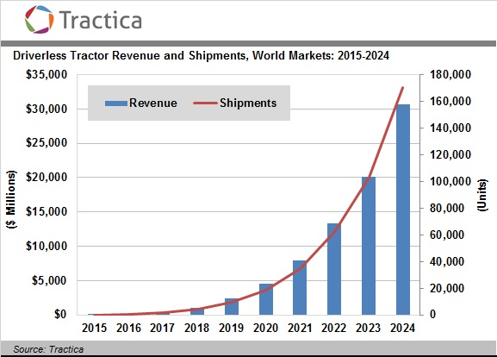

Artificial Intelligence is intelligence exhibited by machines who are made to fulfill certain goals

with a maximum success rate. AI is the software and robotics is the body of these machines. From the beginning of agriculture, man - kind have invented all sorts of different tools and machines to help them with farming duties. As time has gone by we have developed as a species and as a result we have created more advanced versions of theses early farming tools. Thanks to the incredible research and improvement of AI and robotics as a whole we are now capable to further revolutionize the way in which we farm. An added bonus is that AI machines can complete tasks quicker than a human and with more success. However this may result in a future where farming will no longer be a profession. Initially the introduction of such technology will cause unemployment in the farming industry. However it is nearly inevitable due to economic advantage of cheaper labour and products. Even Though this fact is very true it doesn’t validate the action of replacing farmers with robots! We endeavour to go in depth into this subject in our documentary.

**About the Team**

TechBytes is a group of Irish students currently studying Computer Science in Trinity College Dublin. Our aim for this project is to provide information concerning the role of technology in Irish society, particularly in agriculture and manual labour. Members of TechBytes can be contacted for more information through the email addresses provided: [olorunns@tcd.ie](mailto:olorunns@tcd.ie)

[saphilli@tcd.ie](mailto:saphilli@tcd.ie)

[tprasad@tcd.ie](mailto:tprasad@tcd.ie)

[oreskovt@tcd.ie](mailto:oreskovt@tcd.ie)